Lesson Plan # 6: Commercial Travel/ Then and Now

Aim: How has commercial air travel changed since the glory days of Floyd Bennett Field in the 1930’s?

Instructional Objectives:

Students Will Be Able to: (SWBAT)

- Compare and contrast the passenger experiences on early commercial airlines to those of today.
- Explain how improvements in air speed have led to the popularity of air travel over other forms of commercial transportation.
- Use a simple mathematical formula to determine travel times, speeds and distances.
- Describe how commercial air travel has helped to make the world a “smaller place” to live.

Standards: Standards: Common Core (as listed in the NYCDOE websites)
ELA standards for grades 6-12)
College and Career Readiness Anchor Standards for Reading: 1, 2,3,4,7,8,9,11
Reading Standards for Informational Text 6-12: 1,2,3,4, 7,8,9
College and Career Readiness Anchor Standards for Writing: 1,2,3,4,5,6,7,8,9,10, 11
College and Career Readiness Anchor Standards for Speaking and Listening: 1,2,3,4,5,6
College and Career Readiness Anchor Standards for Language: 1,2,3,4,6
Standards for Literacy in History/Social Studies, Science, and Technical Subjects 6-12
College and Career Readiness Anchor Standards for reading: 1,2,3,4,5,6,7,8,10
College and Career Readiness Anchor Standards for Writing: 1,2,3,4,5,6,7,8,9
College and Career Readiness Anchor Standards for Speaking and Listening: 1,2,3,4,5,6

Motivation: two comparative photos of planes

Questions:

- Enclosed are two photos of commercial aircraft. Examine the photos carefully and briefly list the similarities and differences between the two planes.
- If you were planning a trip from New York City to Los Angeles, California what would be your concerns and/or preferences about traveling on these two planes?
- How long would it take you make this coast-to-coast trip (NYC to LA) if you left NYC at 6:00AM in 1937? How long would this trip take today in 2011?

Comparative Photos of Commercial Aircraft: Then and Now

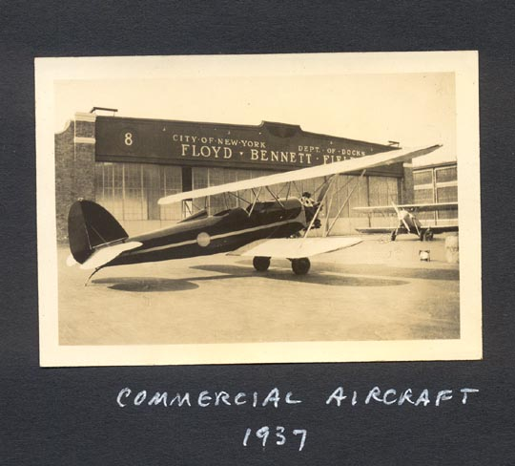

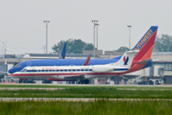

Historical Information for Teachers

While most adults living in the New York City Metropolitan area are familiar with such local commercial airports as LaGuardia, JFK International, and Newark International, many folks are not aware of the fact that Floyd Bennett Field (located on Barren Island in Brooklyn, New York) was originally slated to be the first municipal airport back in June of 1930. Named after Floyd Bennett, the World War I aviator and world explorer who piloted Admiral Richard E. Byrd on his historic flight over the North Pole in 1926 (which earned him the Congressional Medal of Honor), the Barren Island site which is located at the south eastern part of Brooklyn, was chosen as an ideal location for the early airport due to its proximity to both Manhattan and easy accessibility to the Atlantic Ocean.

Starting in 1928, New York City and its Mayor, James (Jimmy) Walker pushed to get Barren Island transformed into a municipal airport. Although public air travel was a financial plus, it was really the quest to secure a lucrative mail contract from the U.S. Postal Service that became the key motivating point to develop a commercial airport. Over one million dollars was spent over the next three years which included filling up Jamaica Bay with sand so that Barren Island would be connected to the surrounding islands creating more of a peninsula affect, and raising the ground 16 feet above the high tide level. In addition, Flatbush Avenue was extended passed Avenue U all the way to shoreline (which today is the site of the Marine Parkway Bridge, (which was renamed the Marine Parkway-Gil Hodges Bridge in 1978, after the great Brooklyn Dodger Baseball Hall of Famer).

Floyd Bennett Field was completed in 1930, and consisted of an air terminal building capped with a flight tower, two perpendicular cemented runways, with an underground tunnel from the terminal to the taxi runway, eight hangars north of the tower running parallel to Flatbush Avenue, and a public parking area. The terminal included “a barbershop, weather room, pilot’s lounge, passenger lounge, and restaurant,” all in a modern art deco design which was very popular at that time.

“When it was completed, the municipal airport had a sophisticated lighting system for night landings, exceptional runways, and good maintenance and administration facilities. It received an “A1A” rating from the Commerce Department. New York had one of the finest facilities of its kind in the country.”

Failure to secure the mail contract in 1935 put an end to Mayor LaGuardia’s dream of Floyd Bennett Field becoming a profitable and successful airport for the City of New York. With the construction of the Paluski Skyway leading to the newly built Holland Tunnel, made Newark the choice airport with a direct route to mid-Manhattan. Even with the idea of adding a seaplane port, the transporting of mail in an efficient time frame was not as direct as transporting it from Newark. By 1936, the plans for LaGuardia airfield in northern Queens made it an ideal spot for the city’s new municipal airport. By the end of the decade, the usefulness of Floyd Bennett Field as a major municipal airport was gone, as the United States Navy became interested in utilizing it as a first line of defense against Floyd Bennett Field/ possible invasion during wartime.

Although Floyd Bennett Field did not become the commercial success that it had been designed for during the 1930’s, it still became one of the more popular airfields in the nation, hosting some of the greatest flyers of the “Golden Age of Aviation” on their way to setting some very impressive speed and air travel records. Some of the flyers that will be cited in the lesson will be Emily Earhart, Jacqueline Cochran, Howard Hughes, Wiley Post, Douglas “Wrong Way” Corrigan, Roscoe Turner, General Italo Balbo, Laura Ingalls, and Major James Doolittle.

Mini Lesson: Background information for Students (10 minutes—do a brief power point lesson)

If you were planning a trip tomorrow from New York City, New York to Los Angeles California which metropolitan (city) airport would you most likely leave from? If you answered LaGuardia in Queens, JFK International also in Queens, or Newark International in New Jersey, you would be absolutely correct. If you had planned this trip in 1930, during the “Glory Days” of early aviation, you might have left from Floyd Bennett Field in the south east end of Brooklyn where Flatbush Avenue ends and where the Marine Parkway-Gil Hodges Bridge begins as a main entrance to Rockaway and Jacob Riis Beaches.

What many people do not know is that before LaGuardia and JFK International airports were ever planned and Newark International was in its infancy, Floyd Bennett Field was already the first metropolitan airport used for commercial travel.
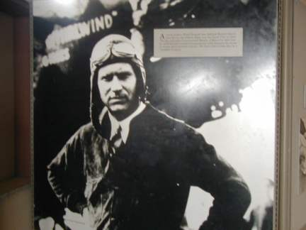

Floyd Bennett

Named after World War I Navy pilot and Polar Explorer (he piloted the plane that took Admiral Richard E. Byrd over the North Pole in 1926, an event that earned them both the Congressional Medal of Honor), Floyd Bennett was ideal choice of Mayor James “Jimmy” Walker as New York City’s first commercial airport. Barren Island was chosen as the site for the construction of Floyd Bennett Field because of its easy accessibility to Manhattan, the cross winds making it excellent for takeoffs and landings, and the fact that there were no obstructions surrounding the area.

The first step to the construction of the field was to bring in millions of tons of land fill to connect Barren Island to some of the surrounding islands and raising the land 16 feet above the flood level. This was followed by the extension of Flatbush Avenue past Avenue U (where Kings Plaza is today) to the shoreline (where the Marine Parkway-Gil Hodges Bridge now stands).

Barren Island during hydraulic landfill operation 1928---Smithsonian Institute

All of this construction began in 1928, and by the time it was completed in 1932, the City had spent over 10 million dollars which included, two perpendicular cement paved runways, an administrative building with a flight tower on top of it, eight hangars north of the administrative building with lean-tos (small sheds) for mechanics, and lights for night flights. The administrative building which would be the main terminal included a barbershop, a telegraph room (main means of communications before phones became popular), a café, pilot’s lounge, and a newsstand. All this designed in an Art Deco fashion (very popular décor at the time).

View looking north from the Administrative Building Control Tower showing hangar 5 and apron area---1933---Smithsonian Institute

With all of this money spent over four years on constructing a commercial airport, why is it that no one really remembers Floyd Bennett Field as the first municipal airport?

The answer lies in the fact, that the real potential for income as a commercial airport could only take place if New York City could secure a contract with the U.S. Postal Service for continental and intercontinental transportation of the mail, which it failed to get.

There were several factors that played a role in its failure to get that contract:

- Floyd Bennett Field was too far from the main post office in mid-town Manhattan.
- Newark after the construction of the Holland Tunnel was a more direct and shorter route to NYC.
- City officials were beginning to look at the site in northern Queens (today LaGuardia airport).

Administration Building, 1933

Although Floyd Bennett’s history as a commercial airport was short lived, it was still a very popular site as many early aviators set travel and speed records during the “Golden Age of Aviation. Some of those individuals and their records are listed below:

Group task: Students will work in pairs. Each group of two will get an information sheet with the record-breaking flights of a famous flyer during the Glory Days of Flight. Students will work together to answer the travel question attached to their flyer (hints are listed with each handout) and/or the bonus question and/or the differentiation task. (Total time allocated for this task is 20 minutes).

Emily Earhart,

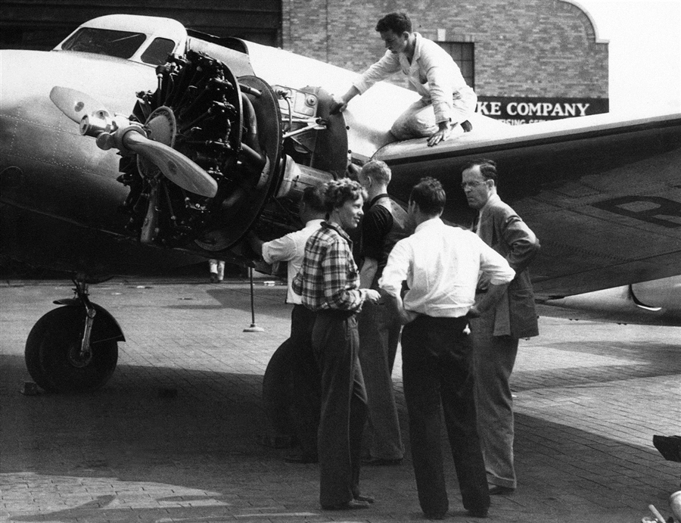

In this Sept. 4, 1936 file photo, Amelia Earhart is talking with her husband George Palmer Putnam, right, and friends in New York, before taking off from Brooklyn's Floyd Bennett field for Los Angeles in the Bendix Trophy race. Floyd Bennett Field was built between 1928 and 1931 and quickly became the preferred launching site for record-setting flights by Howard Hughes, Earhart, Wiley Post and other aviation pioneers. The Navy took over the airport in 1941 and most of the airport closed for good in 1971, but the New York Police Department still uses a corner of it as its helicopter base.
On July 24-25, 1932 Amelia Earhart set a coast-to-coast flight record by traveling from Los Angeles to the New York City area in 19Hours and 5 minutes. If she traveled approximately 2,442 miles, what was the approximate speed that her Lockheed propeller plane was flying?
Hint: Use the mathematical formula of Rate X Time = Distance (R x T = D)
To find the speed you need the following formula (Rate = Distance divided by Time)
Answer: approximately 128 mph. ( Do not give students the answer until they have tried to calculate the travel rate on their own).
Bonus question: If Ms. Earhart left Los Angeles at 6AM (Los Angeles time, what time did she arrive in the New York City area? (Hint: Remember the time zones)
Differentiation task: After reading the Historical note below, have students create a mock interview with Earhart on her record-breaking flight. Student should create at least two questions they would ask and a short possible response by Ms. Earhart.
Historical Note: Mrs. Putnam (Earhart) said she negotiated the first 1,000 miles of her trip at an average speed of 125 miles an hour. After passing over Texas, where thundershowers slowed her up, she found a tail wind that boosted her speed for the last 2,000 miles of the flight up to 160 miles an hour. (Earhart’s married name was Putnam)
“I was so determined to get here,” she related, “that I skimped my gas. Otherwise I believe I would have broken the record. The last time on my unsuccessful trip, I flew a compass course; this time I followed the air lanes—which makes the trip about 100 miles longer—but I cut my corners a little bit.”
Mrs. Putnam skimped her gas by working the throttle gradually and keeping a moderate speed. More gasoline is consumed per mile at high speeds and the aviatrix decided to sacrifice speed to make certain her 460-gallon fuel supply would last until she reached Newark.

Jacqueline Cochran
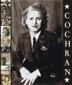

On September 23, 1938, Jacqueline Cochran completed the Transcontinental Bendix race from Cleveland Ohio to Los Angeles, California, a distance of 2,042 miles in a remarkable 8 hours, 10 minutes and 30 seconds. How fast was she traveling?
Hint: Use the mathematical formula of Rate X Time = Distance (R x T = D)
To find the speed you need the following formula (Rate = Distance divided by Time)
Answer: approximately 250 mph
According to the official Bendix Transcontinental Records, Jacqueline Cochran recorded an approximate speed of 249.51 mph. The difference is the plane going into the wind. (This must be explained to the students)
Differentiation: Create a newspaper headline announcing Ms. Cochran’s new flight record.
Bonus question: If Ms. Cochran left Cleveland at 9:00AM, what time would she arrive in Los Angeles?
Students that may have difficulty doing math may create a Bendix award poster honoring Cochran’s victory. The poster must include the recorded victory time, the distance between Cleveland and Los Angeles, and the speed traveled by Cochran.
Howard Hughes

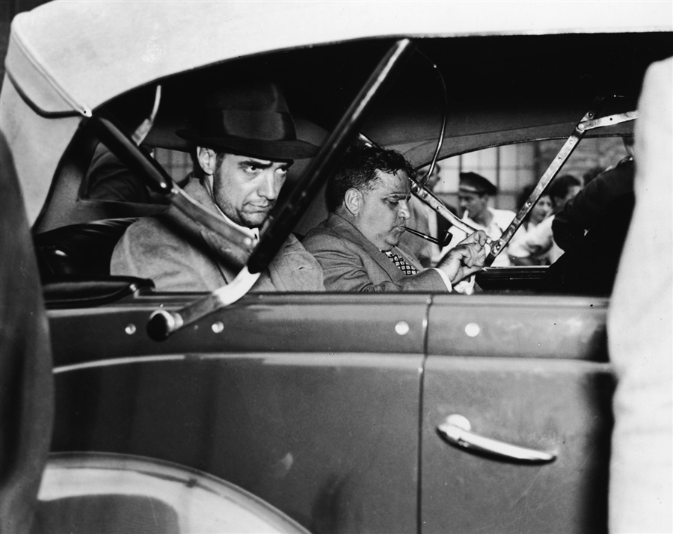

American industrialist, aviator, and film producer Howard Hughes (1905 - 1976) (left) sits in a car with New York Mayor Fiorello H. LaGuardia (1882 - 1947), who lights a pipe as the car leaves Floyd Bennett Airfield, New York, New York, July 14, 1938. Hughes, who looks very tired and unkempt, had just landed his plane at the field after setting a new speed record for flying around the world (3 days, 9 hours, and 17 minutes--more than four days faster than the old record).

On April 21, 1936 Howard Hughes flew his Northrop Gamma, Wright Cyclone engine propelled plane from Floyd Bennett Field to Miami Beach, Florida in 4hours, 21 minutes and 32 seconds at an approximate speed of 259 mph.
How far is Miami airport from Floyd Bennett Field in flying miles?
Hint: Use the mathematical formula of Rate X Time = Distance (R x T = D)
To find the speed you need the following formula (Time = Distance divided by the Rate of speed)
To find the speed you need the following formula (Rate = Distance divided by Time)

Answer: approximately 1,126 flying miles.
Differentiation: Write a short letter to President Franklin D. Roosevelt indicating why you think Mr. Hughes should win a medal for his famous flights).
Bonus question: If a Boeing 747 commercial jet was to leave Brooklyn today and travel to Miami Beach at a flying speed of approximately 614 mph, how long would that trip take?
Answer: Approximately 1 hour and 58 minutes.
- Students who have trouble doing math, may create a short story about a ride on a commercial jet. The story may be from a personal experience or one that an adult has told the student.
- Students may draw a picture of a commercial jet they have seen in a book or in person.

Wiley Post,

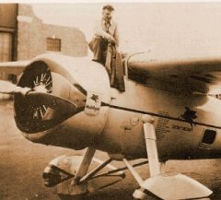

In March of 1935 he was able to reach the stratosphere (over 17,000 feet in altitude) and with the help of a tail wind fly his plane at a speeds of 279 to 340 mph in a trip from Burbank, California to Cleveland, Ohio in 7 hours, 19 minutes. The recorded flying distance from Burbank was 2,035 miles what was the average speed of the plane during this trip?

Hint: Use the mathematical formula of Rate X Time = Distance (R x T = D)
To find the speed you need the following formula (Rate = Distance divided by Time)
Answer: Approximately 278 mph (Note that the engine was made to max out at 179 mph)

Bonus: In a brief sentence or two explain why a plane built to fly 179 mph was able to hit speeds of 240 mph?

- Students who have trouble doing the math, may create a short story about a ride on a commercial jet. The story may be from a personal experience or one that an adult has told the student.
- Students may draw a picture of a Wiley Post’s plane “The Winnie Mae” they have seen in a book or in person.
- The teacher may want to explain the concept of what happens when planes leave the atmosphere and begin to enter space. Examples may be found in books or articles on current space travel experiments made by NASA.
- www.time.com/time/magazine/article/0,9171,769305,00.html - Similar
- wiki.answers.com/Q/Why_aeroplanes_do_not_fly_high_in_the_strato... - Similar

Douglas “Wrong Way” Corrigan,

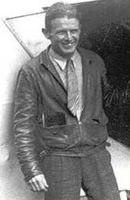

On July 17, 1938 Douglas Corrigan took off from Floyd Bennett with a fight plan that stated his destination as Los Angeles, California. Once in the sky, Corrigan’s plane banked sharply to the right and did an about face into the eastern skies instead of heading west, promptly disappearing into the clouds. Twenty-eight hours and 13 minutes later he set his plane down in Dublin, Ireland. Nick-named “Wrong-way” by the media, Corrigan had realized that in the process of making a so called “mistake”(which he blamed on the cloud conditions and a faulty compass) he had in fact set a new world’s record for flying over the Atlantic Ocean.

Question: If Mr. Corrigan averaged 106 mph, how many air miles did Wrong-way Corrigan log in his cross-Atlantic record-braking trip?

Hint: Use the mathematical formula of Rate X Time = Distance (R x T = D)
Bonus: Write a brief paragraph as to why Corrigan made a wrong turn? Or did he? (Some additional student research may be needed by Googling Corrigan biography or consulting the citation listed below in the footnote.)

Roscoe Turner,

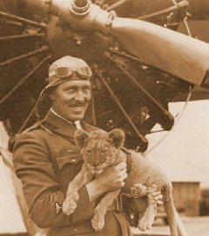

On November 14, 1932 Roscoe Turner flew from Floyd Bennett Field to Burbank, California establishing a new east coast to west coast record of 12 hours, 33minutes in his Wendell-Williams , PW motored plane.

The distance between FBF and Burbank, California is approximately 3,928 miles. What was the approximate speed Cochran traveled during his historic flight?
Hint: Rate=Distance divided by time.

Bonus Question: Four months after Amelia Earhart made her record-breaking flight from the Los Angeles area to the New York City area, Roscoe Turner was able to fly from Floyd Bennett Field in Brooklyn, New York to Burbank, California, approximately 6.5 hours faster than the famous Earhart. After doing some research and citing your sources, explain why a similar coast-to-coast trip took Turner less time. (Hints for the teacher: air speed, tail winds, engine of the plane, flight path, and refueling time).

Differentiation: Have students plot the flight path of the two pilots on a map of the Untied States identifying the different flight paths and flying conditions at the time the trips were made in 1932.
Presentation Time: Teacher/Facilitator will call on several students to present their answers and/or work. (10 minutes)

Exit question/task: How has improved technology in planes made the world a “Smaller Place” to live? (5 minutes)

Homework: Write a brief essay answering the question of, “How does commercial air travel in 2011 compare with commercial air travel during the 1930’s during the “Glory Days of Flight”? (Due the next day)

Submitted by
Prof. Michael B. Schoenfeld
Brooklyn College
Graduate Internship Supervisor
Summer 2011

www.oocities.org/floyd_bennett_field/1930s.html - Similar
- www.hankplumley.com/Photo%20Gallery/Aviation/Commercial/index.p... - Similarto Commercial Aircraft Photo Galleries
- www.aero-web.org/history/fbennett/cgasb_fb.htm - Similarto Floyd Bennett Field
- www.aero-web.org/history/fbennett/cgasb_fb.htm - Similarto Floyd Bennett Field
www.bridgesnyc.com/2011/03/marine-parkway-bridge/ - Similar It should be noted that today, the Marine Parkway Bridge connects Brooklyn to Rockaway, Queens near Jacob Riis Park.
www.forgottenny.com/YOU'D%20NEVER%20BELIEVE/floydbennett/floyd... - Similar
Floyd Bennett Field Historic Structures Report, Vol. 1, Gateway National Recreation Area/Floyd Bennett Field/, pg. 25, May, 1981.
Ibid, pg. 34
Ibid, pgs. 47-52. And Notable flights at Floyd Bennett Field (list complied by NPS Michael P. Delano.
Jun 14, 2011 – It's interesting news that Brooklyn will gain a campground after a decision by the National Park Service. As noted in a story earlier this ... photoblog.msnbc.msn.com/_.../6859283-new-yorks-historic-floyd-bennett-field-to-become-nations-largest-urban-campground - Cached
This copyrighted editorial was printed by the Cleveland Plain Dealer (Cleveland, Ohio) on Aug. 26, 1932:
http://en.wikipedia.org/wiki/Bendix_Trophy
- Jun 14, 2011 – It's interesting news that Brooklyn will gain a campground after a decision by the National Park Service. As noted in a story earlier this ... photoblog.msnbc.msn.com/_.../6859283-new-yorks-historic-floyd-bennett-field-to-become-nations-largest-urban-campground - Cached
Northrop Gamma 2A, Sky Chief. The first two Northrop Gammas, ... Engine: 14 cylinder, twin row Wright Whirlwind GR 1510, 785 hp @ 2500 rpm at 8000 feet, gearing 8:5, ... 30-Apr-34. Delivered, TWA / Jack Frye - Wright Cyclone SR-1820 ... kcbx.net/~mhd/Passions/Northrop/gamma.htm - Similar
The Boeing 747 is a widebody commercial airliner and cargo transport, often referred to by its original nickname, Jumbo Jet, or Queen of the Skies. ... en.wikipedia.org/wiki/Boeing_747 - Similar
Biography of the early aviator, Wiley Post, including his record-breaking flights in the 1930s, his solo flight around the world in the Lockheed airplane ... acepilots.com/post.html - Similar
www.britannica.com/blogs/2008/07/2704/ - Similar
Notable Flights at Floyd Bennett Field, U.S. Department of the Interior, National Park Service, Gateway National Recreation Area, Jamaica Bay District Bldg, No. 272, Floyd Bennett Field, Edited by Michael B. Delano, Historic Structures Report, 1981.

